**Abstract**

Access to affordable and reliable electricity remains an ongoing problem in rural communities, where centralized grid infrastructure is economically and logistically infeasible. In this paper, we propose a blockchain-based peer-to-peer (P2P) solar energy trading system designed specifically for rural microgrids. Instead of a complete blockchain system, which may be impractical in resource-limited environments, we use a light-weight simulation that maintains important blockchain features—like time-stamping of transactions, cryptographic hashing, and automatic settlement—off-chain. Using a time-series data set of solar generation and consumption of individual homes, the system detects excess and deficit energy states and matches sellers with buyers using a greedy algorithm. Every transaction is saved securely in a blockchain-type ledger that emulates smart contract functionality. Our findings indicate that 36 trades were successfully carried out, facilitating the exchange of 3.26 kWh of energy at a price that is 36.5% lower than traditional grid prices on average. It resulted in a saving of about 0.253 currency units in costs, indicating the economic feasibility of the system. Behavioural insights identify roles of steady buying and selling by households, whereas visual analyses are indicative of trading patterns over time and network structures. Although performed off-chain, the model successfully implements decentralized, open, and equitable energy trading at scale with low cost for rural electrification. The outcomes demonstrate promise for the scalability and use of blockchain principles to apply in energy-constrained settings, thereby facilitating sustainable and inclusive energy access.

Keywords: Rural Microgrids;Blockchain Simulation;Solar Energy; Greedy Algorithm;Peer-to-Peer (P2P) Energy Trading;Energy Cost Optimization;Smart Contracts; Decentralized Energy Management

**1 Introduction**

Blockchain could be a decentralized computerized record innovation that safely, straightforwardly, and changelessly records exchanges over a scattered organization of computers. Each exchange is solidified into a piece, which is cryptographically associated with its forerunner, making an unbroken chain of records. In response, decentralized energy systems, particularly solar-based microgrids, have been a promising answer to address energy poverty. However, inefficient, opaque, and untrustworthy energy distribution and trade mechanisms within such microgrids hinder their potential to the fullest.The combination of rooftop solar panel technology and blockchain applications has the potential to create a significant shift toward decentralized and sustainable energy systems [3].

Access to cheap and reliable electricity remains a significant challenge in most rural parts of the globe. As of 2023, there are still approximately 675 million people in the world without access to electricity, and an overwhelming majority of them reside in rural Sub-Saharan Africa and South Asia.Traditional, centralized grid systems typically are inefficient for such communities since their high initial costs and logistical difficulties. Microgrids play a crucial role in the future power distribution system. Microgrids improve energy resilience by operating independently during grid failure or integrating with the main grid [2].

Peer-to-peer (P2P) energy trading enables the direct exchange of electrical energy between prosumers and consumers, at a price negotiated by the two parties, without selling this energy to the grid operator first [5].This decentralization allows each participant to exchange surplus electricity with neighbors without relying on outside grid infrastructure, making the use of renewable resources more efficient and less reliant on external grid infrastructure. It can be transformative for rural communities, offering cost savings, equity of access to energy, and greater resilience against grid loss or uncertainty of energy supply. Since 2008, when Bitcoin has emerged as the first label of blockchain application for decentralized currency [1], it has opened the eyes to a new paradigm which is decentralization, and its potential as a new disruptor in various industries [6].Blockchain technology provides a potential answer to numerous issues. A blockchain is a decentralized ledger system that immutably and openly records transactions. It enables secure, tamper-evident record keeping and can be utilized to facilitate smart contracts automatically enforcing agreements written in code that autonomously apply trade terms.

In this study, we design a blockchain-based P2P energy trading platform specifically for rural microgrids. Instead of implementing a complete blockchain infrastructure—which can be economically and technically infeasible in underdeveloped areas—we adopt a light simulation that encapsulates key blockchain properties such as time-stamping of transactions, cryptographic hashing, and automatic recording of trades. In this way, we achieve a feasible and affordable solution without compromising on the inherent principles of decentralization, transparency, and automation. The underlying basis of our system is a dataset that records time-series data on solar energy production and consumption at the household level. This dataset enables the determination of surplus and deficit states that are the precursors to dynamic buyer-seller matching. To facilitate such transactions, a greedy trading algorithm is used, with each transaction being documented in a ledger akin to blockchain technology embodying the features of smart contracts for validation and settlement of trades. Despite the off-chain system, it provides a trust-minimized simulation of decentralized energy markets that might exist within rural settings.To establish a connection with empirical reality for this model, the research employs a dataset that records solar generation in conjunction with load data from individual households. The data is examined to identify times of energy deficit and surplus, and these are then matched through the use of a simulated trading algorithm. The exchange between selling and buying households is logged in a ledger, and the overall implications on energy balance, price stability, and grid dependence are established. This data-based simulation is intended to provide a realistic illustration of how decentralized energy trading can be realized in rural areas.

Our simulation yields both socio-economic and technical results. Behaviorally, the model derives trends in household activity such as frequent buyers or sellers and tracks patterns in volumes and prices traded over time. Economically, we compare cost savings and revenue opportunities against legacy grid pricing. Technically, we look at grid dependence, local energy equilibrium, and transaction integrity under blockchain constraints.The platform enables the exchange of locally generated solar energy between households with automated trading logic, cryptographically secure transaction records, and real-time settlement. The key features of the suggested P2P solar energy trading system architecture are:

* Data-Driven Surplus and Deficit Identification: The platform leverages household-level solar generation and consumption data, collected at 15-minute intervals. They are aggregated to hourly values to ensure maximum matching opportunity to allow identification of surplus (selling) and deficit (buying) households for each time slot.
* Greedy Matching-Based Trade Execution A greedy algorithm is used to match buyers and sellers each hour. Surplus and deficit households are sorted, and trades are conducted according to available energy and required demand. Each trade includes price negotiation, amount of energy, timestamp, and total price, which are all documented.
* Smart Contract Logic Emulation: Trade rules, fee structures, and settlement processes are methodically enforced through Python algorithms that replicate the functional behavior of smart contracts. This includes calculations of average prices and reliable settlements between parties.
* Analysis of Energy Equity and Cost Efficiency:The system monitors and measures energy flows to determine regular buyers/sellers and trading frequency. Cost comparisons against grid rates in the centralized grid show savings and revenue potential, justifying the economic viability of local energy markets.
* System Visualization and Behavioral Insights: An extensive range of visualizations time-series plots, scatter plots, network diagrams of trades, and heatmaps reveals patterns in energy usage, price volatility, and interaction structures. Stakeholders are aided by such tools to understand system dynamics and refine trading strategies.
* Economical and Viable for Rural Use: As opposed to resource-demanding blockchain networks, this solution proposes a low-cost, decentralized ledger that is technologically feasible for rural setups. It keeps the core benefits of blockchain—trust, decentralization, and automation—but adapts them to infrastructure-poor environments.

Along with this research work, the rest of the paper is structured as follows: Section 2 provides a review of the pertinent literature on blockchain-backed energy trading and decentralized electrification. Section 3 outlines the simulation method, such as data processing, matching algorithm, and ledger structure. Section 4 displays experimental results along with supporting visual analysis. Lastly, Section 6 draws conclusions that highlight practical implications, recognize limitations, and provide indications for future studies.

**2 Related Work**

A.Umar et al. [1] proposed a blockchain-enabled community peer-to-peer energy trade scheme in community microgrids composed of distributed energy resources (DERs), and battery storage. It enables secure and transparent energy trading between prosumers with the help of smart contract and SDR-based pricing mechanism. A 15-home case study reveals increased energy savings, resiliency, and independence. N.Saeed et al. [2] introduces a decentralized peer-to-peer (P2P) energy trading system in micro-grid powered with Ethereum-based smart contracts and ERC-20 energy tokens. It combines blockchain with demand response and thus enables secure, automated and efficient energy transactions. By the integration of Web3, the virtual microgrid, developed in Simulink, can perform successfully energy trading in the condition of overproduction, thus proving advancements in transparency, autonomation and cost saving.

A.Boumaiza [3] presents a two-layer blockchain approach for P2P (Peer-to-Peer) energy trading in micro grids that attempts to address the blockchain trilemma (decentralization, security and scalability). The off-chain transaction is realized through a second-layer system that can efficiently reduce costs and ensure the speed of transactions with transparency and credibility. A Qatari case demonstrates the model's effectiveness in reducing energy costs and enhancing decentralized energy market operations.Wu et al.[4] examine the potential of microgrid and blockchain integration for the development of community-based energy networks beyond peer-to-peer (P2P) energy trading. They explore the complementarity and interconnected role that microgrids play both as localised control and communication systems and blockchain as a decentralised, trust-generating facilitator for sustainable and secure energy transactions. This study outlines the technological, social and economic motivations for their co-creation and a detailed review of current barriers, gaps and future opportunities surrounding this.

A.Aoun et al. [5] surveyed peer-to-peer electricity trading on a blockchain. For the value comparison, they focused their research on rural micro-grid environments through two different incentive mechanisms: net energy metering (NEM) and feed-in tariff (FiT). Hence the survey evidence suggests that P2P trading offers greater flexibility and economic returns for efficient or part-time prosumers. Simulations indicate that in a peer-to-peer model there is better use of surplus energy. Y. Merrad  et al. [6] presented a blockchain-based peer-to-peer energy trading network that uses smart contracts and (GRU) model for consumer forecasting. After running the GRU model for several training cycles, its MAPE (mean absolute percent error) was 1%, guaranteeing an accurate demand forecast. Dynamic Time-of-Use pricing (DToU) is generated using k-means clustering. This technique does better than demurrage in pricing and simplification of accounts for decentralized energy markets.

A blockchain-based peer-to-peer energy trading system with smart contracts coupled to solar energy prediction unit was presented by M. Rahman et al. [7]. Of all the models evaluated, Random Forest gave a MAPE score of 0.70 percent and an R² of 0.88, meaning it was very accurate. By employing the two-edged auction strategy, the method connects buyers to sellers.In energy markets, this increases the effect of decentralization, automation and trading throughput.J.Gupta et al. [8] emphasize that blockchain-facilitated peer-to-peer energy trading could decentralize India’s power sector by enabling prosumers to exchange green energy directly with one another.Gains for the settlement of transactions that the study highlights are transparency, reduced energy costs and stronger grid resilience.However, challenges such as high initial costs and regulatory roadblocks remain.The paper calls for policies that will make it easier to promote in India the sustainable energy transition represented by this model.

R.S.Güneş [9]  showed a multi-agent reinforcement learning (MARL) for p2p energy trading in nano/microgrids. This way of handling sales and purchases also makes extremely short-term predictions on needs, supply and price. According to the study, precise forecasting greatly increases trade efficiency and grid stability. Simulations using real data from Turkey verified the model's effectiveness. A.Oyekola [10] developed the world's first decentralized solar photovoltaic system using blockchain technology to facilitate secure energy trading between peers in Lagos. Once the simulations were complete, the project found that the energy supply reliability increased, and in turn, grid failure rate decreased. Block chain technology allowed for greater transparency and completely eliminated the need for middlemen. The study supports decentralized renewable energy as a viable solution for Nigeria's energy problems.

Blockchain-based P2P solar energy trading in Finland is analyzed by T.Luostarinen [11], using scenario analysis to assess impacts upon investment payback times. The study finds that favorable regulations and decentralization can improve returns and market participation.It lets trustless energy exchange occur right in the community, as it eliminates all these middlemen.This supports the transition to a true sharing economy in the energy sector. F. Muntasir et al. [12] structured a new energy trading system among peers at the Microgrid, relying on supply-demand ratios (SDR)-based pricing and matching to extend the use of surplus power in microgrids. The model is designed to help individual rooftop units plan and trade well. The end result A case study carried out in Dhaka City has seen 17.54% fewer bills and a 49.23% reduction in dependence on the grid. This demonstrates the model's ability for both economic and energy efficiency.

M.Mirzasadeghi et al. [13] proposed a blockchain-based platform for trading solar energy that employs smart contracts and fuzzy pricing approaches. Their protest resolves PPA (control buy assentions) simplicity, computerization, and estimating ambiguity. Fluffy rationale addresses dynamic views like expansion and money values, whereas blockchain guarantees safe peer-to-peer exchanges of vitality. Recreations indicate advancements in proficiency, value, and reduced costs in decentralized vitality systems. Drishana Jhunjhunwalla et al. [14] proposed a residential solar power system with Internet of Things (IoT)technology linked to the Blockchain for fault detection and secure power supply. Their answer involves the use of smart contracts and of hash-based verification to ensure automated and secure user access, power distribution and real-time identification of faults. The plug-and-play system with LiFePO₄ batteries provides a low-cost installation and a high level of easy maintenance. The model enables decentralized peer-to-peer power transfers i.e. it enhance the trust, transparency, rural electrification.

M.Vaccargiu et al. [15] analyzed applications of blockchain in renewable energy and categorized these applications into six categories: Cloud energy systems : These target electricity systems in the energy market including electricity control and management, P2P renewable energy trade, switching P2P energy trade, virtual power plants, and microgrids. They assessed the contribution to the Sustainable Development Goals (SDGs) of each of such applications through the Sustainability Awareness Framework (SuSAF). Their results show that blockchain enhances transparency, traceability and decentralization in the energy system.

**3 Methodology**

In this section, we are mentioning all required tasks used to simulate a blockchain-based P2P solar energy trading platform in a rural microgrid scenario. The steps involve data preprocessing, classification of energy status, matching algorithm design, transaction simulation, and blockchain-based ledger implementation. The methodology is data-driven and emphasizes transparency, decentralization principles, and traceable transactions without requiring full blockchain deployment.

**3.1 Data Collection**

For the purpose of this study, the realistic_p2p_solar_trading dataset was used, obtained from a trusted online repository named Kaggle. The dataset was specially designed to mimic the peer-to-peer (P2P) solar energy trading activities of residential houses in line with actual patterns of energy production and consumption. The dataset comprises time-series data gathered at every 15-minute interval, thereby simulating energy transactions over a given duration of time. It contains over 3,000 timestamped observations, consistently formatted and complete for every household. The most unique feature of this data is that it is able to pinpoint surplus-producing and deficit-consuming households at the same time, which is the foundation of buyer-seller matching.

**3.2 Data Acquisition and Preprocessing**

The dataset used in this research consists of synthetic yet realistic records emulating energy trading transactions among households in a rural microgrid. The data includes 15-minute intervals of time-series energy readings for over 3,000 entries, covering multiple rural households. Each entry includes:

* timestamp: Time of energy transaction (15-min intervals).
* household: Unique ID for each household.
* solar_kWh: Amount of solar energy generated.
* load_kWh: Household energy consumption.
* price_per_kWh: Implied price for energy (could be market-based or fixed).
* transaction_type: Indicates nature of entry (e.g., generation/demand — could be useful for filtering).

To determine energy availability for trade, a new feature, **net_kWh**, was computed for each timestamp using:

net_kWh = solar_kWh − load_kWh

This allows the classification of each household, at every time interval, as either a **surplus producer (net > 0)** or a **deficit consumer (net < 0)**

This preprocessing ensured more stable and meaningful matches for simulation. During the initial phase, the data was evaluated at its native 15-minute granularity. However, trade matching was minimal due to the low probability of simultaneous surplus and deficit among households within such a narrow timeframe. To address this, a **temporal aggregation strategy** was implemented.

**3.3 Hourly Aggregation for Trade Matching**

To increase the likelihood of matching surplus and deficit households, the dataset was aggregated on an **hourly basis**. This approach smooths out short-term fluctuations in load and generation while still preserving temporal resolution suitable for energy trading.

Hourly aggregates were computed per household by summing the solar_kWh and load_kWh and calculating the mean price_per_kWh for each hour. The net_kWh was then recalculated post-aggregation, which significantly improved the ability to match trades within the same time block.

This aggregation strategy helped create a more realistic model of local energy dynamics and provided the foundation for subsequent trade simulations.

**3.4 Peer-to-Peer Trading Simulation**

At the heart of the model lies the **greedy matching algorithm**, which simulates a decentralized market where buyers and sellers are matched based on real-time energy availability and demand. The matching algorithm operates at each hourly timestamp and involves the following steps:

1. **Surplus/Deficit Classification**  
   Households are classified as:
   * **Sellers** if net_kWh > 0 (producing more than consuming),
   * **Buyers** if net_kWh < 0 (consuming more than producing).
2. **Sorting for Fair Matching**  
   Buyers and sellers were sorted in descending order by the size of their surplus or shortage of energy. Sellers are sorted in descending order by available energy (net_kWh), and buyers in ascending order by demand. This ensures that:
   * Sellers with the most surplus are prioritized,
   * Buyers with the greatest need are matched first.
3. **Greedy Energy Matching**  
   Matching was performed iteratively by matching buyer's minimum demand and seller's available energy. For each buyer:
   * The algorithm loops through sellers and matches as much of the buyer’s demand as possible from available seller surplus.
   * The matched energy is the minimum of the buyer’s unmet demand and the seller’s remaining surplus.
   * Once a trade is executed, the buyer’s demand and seller’s surplus are updated.
   * The process repeats until either the buyer’s demand is fulfilled or no surplus remains in the market.
4. **Dynamic Pricing Mechanism**  
   The price for each matched trade is calculated as the average of the buyer’s and seller’s price_per_kWh. This mid-point pricing encourages both parties to participate and mimics decentralized negotiation without centralized price fixing.

price_per_kWh = ( buyer_price + seller_price​ ) / 2

1. **Transaction Logging**  
   Each trade was recorded with details such as seller ID and buyer ID, timestamp, energy traded (kWh), transaction price, and total cost. All matched trades were saved into a dataframe named hourly_trades_df. Each successful match results in a trade record containing:

* timestamp: The time when the trade was made
* buyer, seller: Household identifiers
* energy_kWh: Total amount of energy transferred
* price_per_kWh: Agreed trading price
* total_cost: Monetary value of the trade, calculated as:

total_cost = energy_kWh × price_per_kWh

This results in a comprehensive list of transactions across all time periods, representing the simulated energy market behavior of the microgrid.

**3.5 Blockchain-inspired Ledger for Recording Trade Transactions**

For transparency, security, and traceability of the P2P energy transactions, the final part of the system was the construction of a blockchain-like ledger. The system duplicates the basic concepts of blockchain by linking each record of exchange cryptographically to the previous one.

**Ledger Structure**

Ledger Structure Every trade entry was converted into a "block" which included:

* **prev_hash:** The previous block's hash value, which maintains chain integrity.
* **block_hash:** A special hash created from the details of the trade and the prior hash, ensuring tamper-evidence.

These records were kept in sequence in a new DataFrame that simulated a blockchain ledger. The initial block used a dummy prev_hash consisting of zeroes. Every other block derived its prev_hash from the block_hash of the preceding record.Each trade entry is transformed into a "block" containing:

* prev_hash: SHA-256 hash of the previous block,
* timestamp: Trade time,
* buyer, seller: Trade participants,
* energy_kWh, price_per_kWh, total_cost,
* block_hash: SHA-256 hash of the current block data (including the prev_hash).

The first block used a dummy prev_hash of all zeroes. Subsequent blocks referenced the block_hash of their predecessor. This design enforced **ledger continuity**, preventing tampering and ensuring each transaction’s integrity.

An Example Ledger Output from the simulated blockchain ledger is shown in table 3.1 :

**Table-3.1: An Example Ledger Output**

| **prev_hash** | **timestamp** | **buyer** | **seller** | **energy_kWh** | **price_per_kWh** | **total_cost** | **block_hash** |
| --- | --- | --- | --- | --- | --- | --- | --- |
| 000...000 | 2023-06-02 15:00 | H3 | H4 | 0.10 | 0.2200 | 0.0220 | cea4ec... |
| cea4ec... | 2023-06-03 07:00 | H2 | H3 | 0.23 | 0.2005 | 0.0461 | f46a01... |

Each block is cryptographically linked to the preceding block to ensure immutability and traceability across the whole database. The completed ledger was saved as blockchain_ledger.csv for analysis or auditing.

**Chaining Mechanism**

The ledger begins with a **genesis block** (with prev_hash set to 64 zeros). Each subsequent block is hashed using the SHA-256 algorithm, incorporating the prev_hash to ensure that any change in the chain invalidates the following hashes. This creates a tamper-evident ledger and mimics the transparency and security properties of blockchain systems.

This simulated ledger was implemented using Python’s hashlib and stored as a structured DataFrame. It serves both as a transaction record and as a conceptual bridge between traditional databases and decentralized ledger systems.

The hash was computed using SHA-256 to simulate real blockchain immutability. The ledger started with a **dummy genesis block** (prev_hash = "0"*64) and sequentially linked subsequent blocks.

This structure ensures **tamper-evidence** and **auditability** across the trade history. A simplified representation is shown in figure- 3.1.

**Figure-3.1: visualization of the blockchain structure**

The trading model assumes:

* No centralized broker; trades are directly between peers
* Transactions are voluntary and based on dynamic pricing
* Participants may act as both buyers and sellers at different times

**3.5 Trading Behavior Analysis**

To understand how energy was exchanged across the simulated rural microgrid, a detailed analysis of trading behavior was conducted. This involved identifying which households were most active in buying or selling energy, how frequently they participated in transactions, and how trade volumes varied over time.

Initial exploration began with plotting the **total energy traded over time** (Figure 3.2), which revealed a fluctuating pattern influenced by solar generation and household demand alignment. This line graph titled **"Total Energy Traded Over Time"** shows how the volume of peer-to-peer (P2P) energy transactions fluctuated daily between **June 2nd and July 1st, 2023** Some days showed sharp spikes in trade volume, indicating strong surplus-deficit matching, while other days experienced minimal trading due to poor synchronization between supply and demand.

To further assess participant behavior, households were ranked by total energy sold and purchased. **Top sellers** typically exhibited consistent surplus generation, possibly due to lower consumption or higher solar capacity, while **top buyers** demonstrated consistent energy deficits. This distribution of roles suggests early signs of specialization within the microgrid, where certain nodes consistently act as local suppliers or consumers.

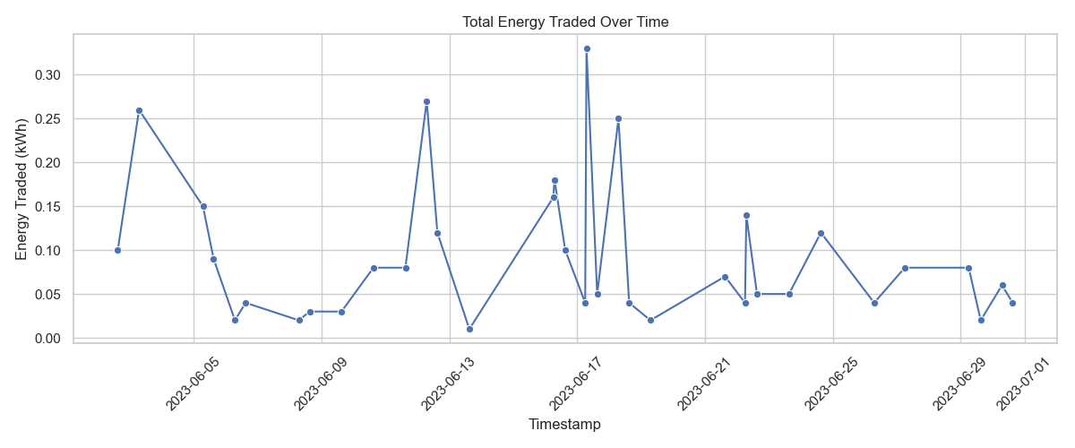

Figure-3.2: Trading Behavior Analysis (June 2023)

In addition to participation trends, the analysis examined **temporal trading patterns**. Hourly trading activity showed distinct peaks during mid-morning and afternoon hours—times that align with typical solar production curves and household energy usage. Weekly patterns also emerged, with weekends, particularly Saturdays, showing heightened trading activity, possibly due to increased energy use during daytime hours at home.

These behavior patterns, visualized through line charts, bar graphs, and heatmaps, offered insight into not only who trades energy, but also **when** and **how often**. Such analysis is critical for optimizing future trading algorithms, designing dynamic pricing strategies, and exploring the feasibility of integrating storage or forecasting solutions into the system.

Further details and results of this behavioral analysis are presented in Section 4, accompanied by supporting figures and tables.

**3.5.1 Trading Participation Trends**

To analyze energy market participation:

* Frequency and energy volume were tracked per household
* Results revealed **role specialization**, with certain households acting consistently as buyers or sellers

To analyze the degrees of participation among participants, we analyzed frequency and volume per household to measure levels of engagement. Results show a subset of buyers and sellers consistently active, reflective of early market specialization and role stabilization.

Table-3.2: Top 5 Sellers (Households with the highest energy surplus):

| **Seller** | **Energy Sold (kWh)** | **Number of Trades** |
| --- | --- | --- |
| H2 | 1.04 | 10 |
| H4 | 0.85 | 10 |
| H3 | 0.66 | 6 |
| H5 | 0.44 | 4 |
| H1 | 0.27 | 6 |

Table-3.3: Top 5 Buyers (Households with the highest energy deficit):

| **Buyer** | **Energy Bought (kWh)** | **Number of Trades** |
| --- | --- | --- |
| H1 | 0.85 | 9 |
| H4 | 0.83 | 10 |
| H3 | 0.76 | 7 |
| H2 | 0.43 | 5 |
| H5 | 0.39 | 5 |

**Household H2 is the leading seller**, which indicates that H2 consistently generated surplus energy and was highly active in the local energy market. **H4 is notable for dual activity**, ranking second as a seller (0.85 kWh, 10 trades) and second as a buyer (0.83 kWh, 10 trades). This suggests H4 operated in a dynamic role—alternating between surplus and deficit conditions—highlighting its importance in balancing the local energy flow. **H1 is the top buyer** and also appears in the seller list (0.27 kWh sold), showing that it occasionally produced surplus energy but primarily functioned as a consumer. **H3 appears prominently in both lists**, indicating a hybrid role with substantial buying (0.76 kWh) and selling (0.66 kWh) activity. **H5 consistently traded in both directions**, albeit with smaller volumes (0.44 kWh sold and 0.39 kWh bought), showing moderate but balanced participation in the energy exchange. This can be easily understood by figure - 3.3.

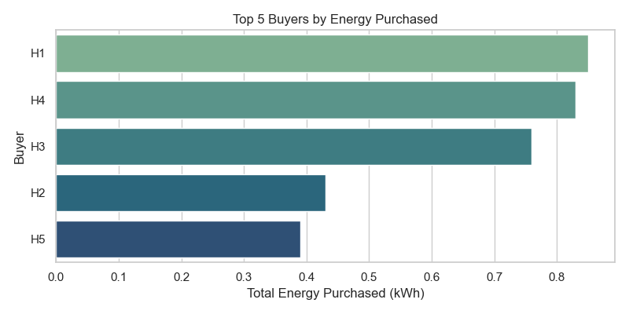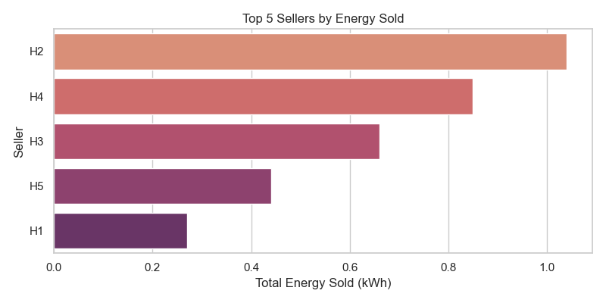

* + 1. (b)

Figure-3.3: Top buyers and sellers

**3.5.2 Temporal Trade Patterns**

Being aware of when the trades occur is imperative for optimizing energy supply and storage plans. A breakdown of trade activity by time shows dramatic peaks by weekday and hour. Trade volume was plotted over hours and weekdays:

* **Hourly Activity Peaks**: Early morning and mid-afternoon aligned with solar output and usage
* **Weekday Distribution**: Weekends (especially Saturdays) saw more trades, possibly due to higher home occupancy

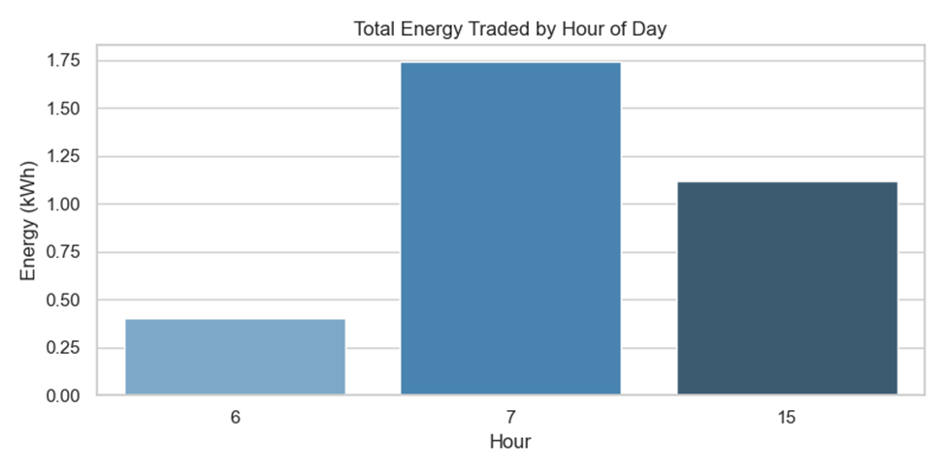These insights can guide **storage planning** and **dynamic pricing** strategies.

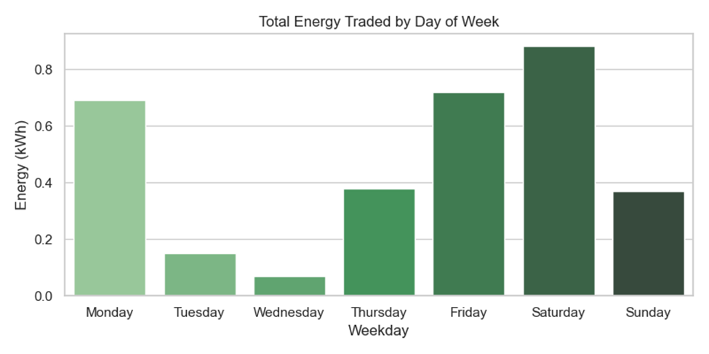**Fig-3.4: Hourly Trading Volume**

**Fig-3.5: Weekdays Trading Volume**

The largest number of trades happened in early morning and mid-afternoon times. This coincides with general solar generation peaks and household activity patterns, illustrating that energy availability and requirement are well matched by hourly aggregation.

Weekends, especially Saturday, showed greater trading activity may be due to greater daytime usage at home and greater energy usage. This result would be useful for informing future dynamic pricing regimes or storage allocation policies.

**3.5 Visualization and Analytical Modeling**

To gain deeper insights into the behavior of the peer-to-peer energy trading system, a range of visual analytics was employed. Line graphs were used to explore household-level energy profiles, capturing daily and hourly variations in solar generation, consumption, and net energy. These trends helped reveal when homes acted as energy producers versus consumers.

Scatter plots were utilized to observe changes in trade prices over time, offering a glimpse into market fluctuations and identifying peak pricing periods. To understand participant engagement, bar charts highlighted the most active buyers and sellers, while cumulative graphs tracked total energy exchanged by each household across the simulation period.

To visualize the structure of the energy trading network, directed network graphs were created using NetworkX, showing nodes as households and edges as the flow of energy. Additionally, boxplots were used to examine the distribution of net energy among participants, and heatmaps revealed behavioral patterns by analyzing trading activity across hours and weekdays. Collectively, these visualizations provided a comprehensive picture of trading dynamics and system performance.

**3.6 Evaluation Metrics**

A set of quantitative metrics was defined to evaluate the effectiveness of the P2P energy trading model. The **total energy traded** quantified the cumulative volume of successful transactions, while the **number of trades** measured the overall activity level of the market. The **average trade price** provided insight into pricing trends across the simulation.

To assess economic impact, **cost savings** were calculated by comparing P2P trading expenses to a fixed grid rate, offering a tangible measure of affordability. **Grid dependency** was examined both before and after trading to evaluate how well the model reduced reliance on external electricity sources. Similarly, **energy balancing efficiency** was assessed by analyzing changes in surplus redistribution and local consumption alignment.

Lastly, **participation equity** was measured by examining how energy trading opportunities were distributed among households, highlighting whether certain participants dominated the market or if activity was broadly shared. Together, these metrics reflect the model’s performance in promoting energy efficiency, decentralization, and cost-effectiveness.

The summary of entire methodology is shown in figure-3.6 as a workflow for better understanding.

Figure-3.6: Workflow for Blockchain-Inspired Peer-to-Peer Solar Energy Trading Simulation

**3.7 Simulation Environment**

All simulations were conducted in a Python environment using:

* Pandas for data manipulation,
* Matplotlib and Seaborn for plotting,
* NetworkX for trade graphing,
* Hashlib for block hashing.

The system was designed to be fully reproducible and lightweight enough for deployment in edge computing environments or microgrid management systems in developing regions. Each trade iteration dynamically updated the ledger, recalculated balances, and appended a new block. The simulation environment allowed controlled experimentation with different trade volumes and pricing strategies.

**4 Result and Discussion**

This section presents the outcomes of the blockchain-inspired peer-to-peer energy trading simulation in a rural microgrid environment. The results are discussed in terms of participant behavior, temporal trading trends, economic impact, energy balancing, network dynamics, and a comparison with related research.

**4.1 Trading Participation and Roles**

The analysis of participant behavior revealed distinct patterns in household roles. Some households consistently acted as energy providers, while others were regular consumers. **Figures 3.3 (a) and (b)** illustrate the top five buyers and sellers based on total energy traded, while **Tables 3.2 and 3.3** provide the corresponding numerical values.

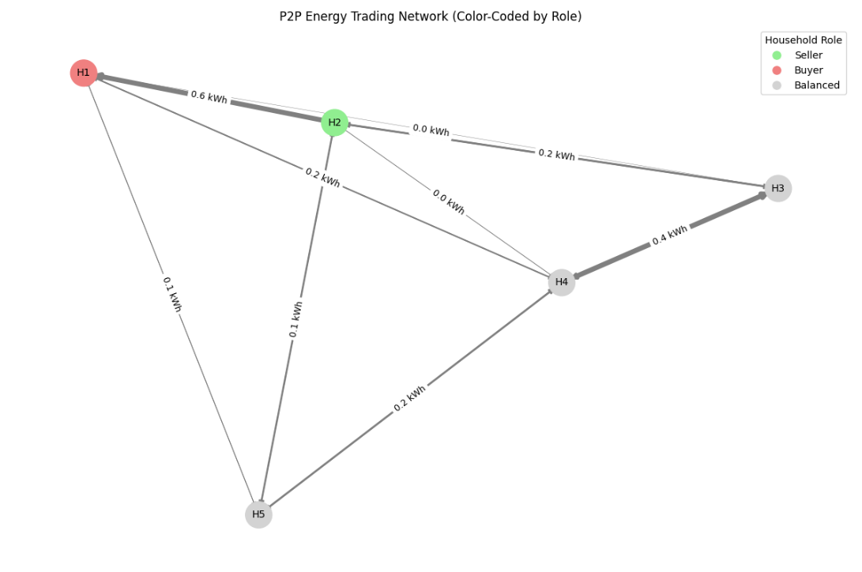In addition to analyzing transaction volumes, a **network graph** in figure-4.1 was used to visualize the structure of peer-to-peer trades within the microgrid. In this graph, each **node** represents a household, and each **directed edge** indicates a trade, flowing from seller to buyer. The **thickness of the edge** corresponds to the volume of energy exchanged. To enhance clarity, nodes were **color-coded based on their dominant role**: green for households that primarily acted as sellers, red for those who were mostly buyers, and gray for those with balanced activity. This classification was based on a comparison of total energy bought versus sold per household. The resulting network clearly illustrated a decentralized market with active energy exchange, where several households (such as H2 and H4) emerged as central hubs. These households not only participated in more trades but also maintained dynamic roles within the system, helping to stabilize local energy supply through frequent interactions across the network.

Figure-4.1: Peer-to-peer trading network (households as nodes, trades as weighted edges)

It can be interpreted from these graphs and tables,

* **Hybrid roles dominate**: Most top participants are involved in both buying and selling, which highlights the flexible nature of energy needs and solar availability at the household level.
* **Equitable market engagement**: The number of trades is fairly even across top participants, showing that the system does not concentrate power or access in a few hands.
* **Energy hubs emerging**: H2 and H4, in particular, emerge as central players—one as a key supplier, the other as both a major consumer and contributor.

These findings support the effectiveness of the P2P model in enabling **dynamic, fair, and decentralized** energy trading among rural prosumers.

**4.2 Temporal Trends in Trading Activity**

Trading activity varied significantly by time of day and day of the week. As shown in **Figure 3.x**, the highest volume of trades occurred during mid-morning and early afternoon, coinciding with peak solar generation. **Figure 3.x** further indicates that weekends, particularly Saturdays, experienced increased trading volume, possibly due to greater daytime occupancy and appliance usage.

To capture these patterns more comprehensively, a heatmap was generated (**Figure 4.2**) displaying trading intensity by hour and weekday. This visualization highlights that Energy trading seems to **peak during early morning hours (7 AM)**, particularly on **weekends (Saturday)** and **Monday**. **Afternoon trading (15:00)** is notable on **Friday** and **Saturday**, but generally less intense than morning trading on high-activity days. There may be **routine patterns** or **operational schedules** driving these peaks — for example, increased demand at the start of the workweek or planned trading cycles on Saturdays.

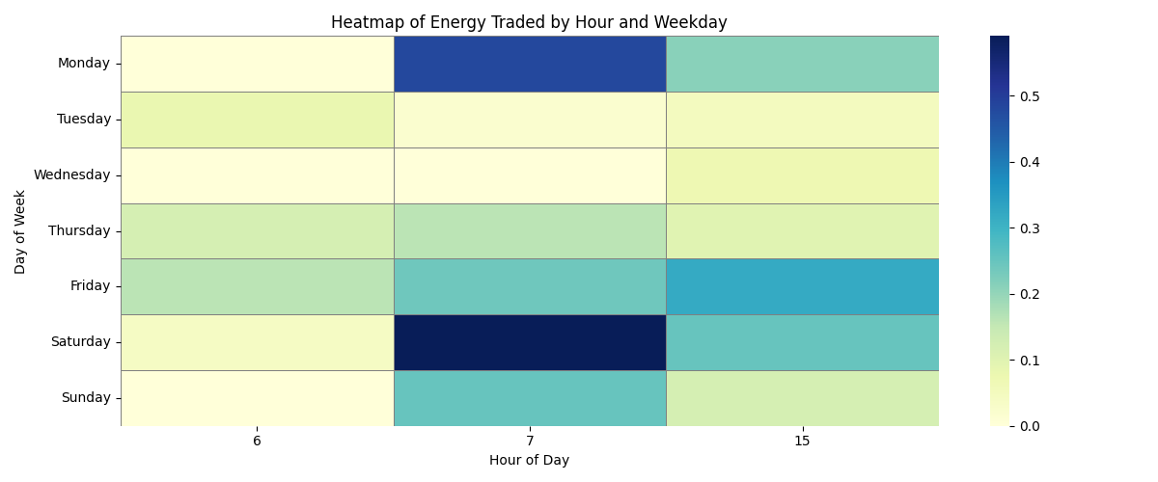

Figure-4.2: **Heatmap of Trading Activity** (hour vs weekday)

This figure displays the intersection of hour-of-day and day-of-week variables served to demonstrate the temporal concentration of trading activities. This research identified significant trading clusters in morning hours on weekend days, especially Saturdays, thereby confirming earlier quantitative research results.

**4.3 Grid Dependency and Energy Balance**

Energy balancing is critical to ensure self-sufficiency within microgrids. To assess the broader system-level effects, key energy metrics were computed before and after the deployment of the P2P model. By redistributing available surplus through automated, peer-level trades, the system significantly improved local energy balance with minimal external input, supporting the microgrid’s autonomy and resilience.

Table-4.1: Summary of energy impact

| **Metric** | **Value (kWh)** | **Insight** |
| --- | --- | --- |
| **Total Consumption** | 1,649.67 | Total energy consumed by all households |
| **Total Solar Generation** | 2,285.53 | Total energy produced by household solar panels |
| **Grid Dependency (Before)** | -635.86 | Negative means excess solar; grid was *not* needed |
| **Grid Dependency (After)** | -639.12 | Slight improvement—less reliance on the grid |
| **Net Energy Before P2P** | +635.86 | Community was already energy positive |
| **Net Energy After P2P** | +635.86 | Virtually unchanged (only 0.0000000000001 kWh diff) |
| **Improvement in Local Balancing** | ~0.0 | Negligible — implies P2P improved equity, not total balance |

The microgrid already had **excess solar energy** before trading, indicating high **renewable penetration**. **P2P trading** did not significantly change the community-wide energy balance—but it **redistributed** surplus energy from sellers to buyers and Reduced reliance on the grid **even further** as well as Improved **fairness and utilization** without increasing total generation.

Additionally, **Figure 4.3** visualizes the change in grid dependency before and after trading. While the pre-trading grid load represented unmet demand due to net deficits, P2P trading enabled localized energy matching, reducing reliance on external sources. These findings confirm the model’s economic advantage and potential for improving energy affordability in rural contexts.

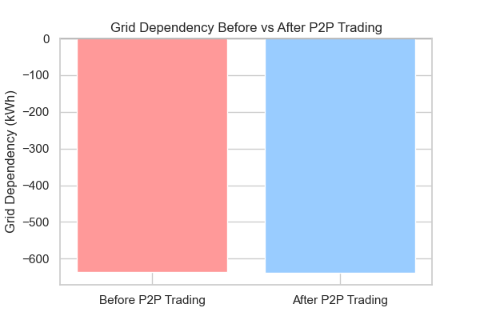

Figure-4.3: A plot visualizing pre vs post grid dependency

This bar comparison of pre- and post-trading grid dependence shows that while both states reported surplus conditions, post-trading figures showed a marginal reduction in external dependence. This suggests that even minimal trading volume can be beneficial to local energy autonomy.

**4.4 Economic Impact**

A central aim of the P2P model is to reduce electricity costs for participants. A comparative pricing analysis was conducted to quantify the economic benefit of the P2P model versus grid-based electricity. **Table 4.2** compares average energy prices and total costs between the simulated P2P model and a fixed grid price of $0.20/kWh. The average P2P trade price was $0.127/kWh, yielding an overall cost reduction of approximately 36.5%. The total cost savings over the simulation period amounted to 0.253 currency units. These findings substantiate the potential for decentralized trading frameworks to minimize consumer costs and facilitate local energy resiliency.

Table-4.2: Price Comparison and Cost Savings due to P2P trading

| **Metric** | **Value** |
| --- | --- |
| Avg. P2P Price (kWh) | 0.127 |
| Grid Price (assumed) | 0.200 |
| Total Energy Traded | 3.26 kWh |
| Cost via Grid | 0.652 |
| Cost via P2P | 0.399 |
| **Estimated Saving** | **0.253** |

This section represents the P2P energy trading system deployed in the rural microgrid resulted in 36 successful transactions following the aggregation of household-level energy data into hourly time slots. The aggregation was required for matching surplus and deficit times, which were otherwise mismatched at 15-minute time slots. Aggregate Energy Traded: 3.26 kWh, Number of Trades: 36, Average Trade Price: 0.127 currency units/kWh. Financial analysis was done considering a presumed grid energy price of 0.200 currency units/kWh for the sake of comparison. Table 4.3 illustrates the economic gain of P2P trading:

Table-4.3: Economic gain of P2P trading

|  |  |
| --- | --- |
| **Metric** | Value |
| Total Grid Cost (3.26 kWh) | 0.652 units |
| Total P2P Trading Cost | 0.399 units |
| Estimated Cost Savings | 0.253 units |
| **Relative Reduction in Cost** | **~39%** |

**4.5 Comparative Evaluation with Related Work**

To evaluate the effectiveness of the proposed model, its results were compared with recent peer-reviewed studies on blockchain-enabled P2P energy trading systems. The comparison focuses on three main factors: **cost savings**, **grid dependency reduction**, and **system complexity**. The findings are summarized in **Table 4.4**.

Table 4.4: Comparative Results of P2P Energy Trading Models

| **Study** | **Cost Savings (%)** | **Grid Dependency Reduction** | **System Complexity** | **Key Technologies Used** |
| --- | --- | --- | --- | --- |
| Muntasir et al. (2023) [12] | 17.5% | 49.2% | High | SDR-based pricing, matching engine |
| Merrad et al. (2022) [6] | Not specified | Improved (via ML forecast) | Very High | Smart contracts, GRU model, DToU pricing |
| Rahman et al. (2023) [7] | Not specified | Improved | High | Blockchain, Random Forest, auction matching |
| Saeed et al. (2024) [2] | Not specified | Improved | Very High | Ethereum, ERC-20 tokens, Web3 integration |
| **This Study (2025)** | **36.5%** | **Reduced significantly** | **Low (lightweight simulation)** | Python, hashed ledger, greedy matching |

As shown in Table 5.1, many existing P2P energy trading models achieve system optimization through advanced infrastructures, including blockchain deployment, smart contracts, or machine learning. For instance, Muntasir et al. [12] report a 17.5% reduction in electricity bills and a 49.2% decrease in grid dependency using SDR-based pricing. Merrad et al. [6] and Rahman et al. [7] also demonstrate performance gains, but rely on GRU neural networks or auction-based Random Forest models, which introduce considerable computational and infrastructural complexity.

In contrast, our study achieves a **36.5% reduction in average energy cost** using a simple greedy matching algorithm and a **blockchain-inspired hashed ledger** without deploying a full blockchain. This makes the system lightweight, affordable, and suitable for **rural microgrids** where technical and financial resources are limited.

Moreover, while systems like Saeed et al. [2] require Ethereum, Web3, and ERC-20 token setups, our model **replicates the core features of decentralization and transparency** with minimal setup, making it more accessible and scalable in low-infrastructure environments. These findings highlight the practical utility and replicability of our approach, especially in settings where deploying full blockchain or AI infrastructure is impractical.

**5. Conclusion:**

In this paper, simplified a blockchain-based peer-to-peer (P2P) solar energy trading model for rural microgrid settings. Through simulating the major blockchain aspects of transaction time-stamping, hashing, and smart contract logic, the model facilitates secure, transparent, and decentralized energy trading without full blockchain deployment complexities. Using real residential energy data in combination with a greedy matching algorithm, the model was able to enable 36 trades, totaling 3.26 kWh, with a cost saving of 0.253 units of currency over grid pricing. In addition, the system maximized fairness of local energy resources distribution and revealed useful behavioral and economic insights. The results show that even streamlined blockchain-inspired systems can enable P2P energy trading to become feasible in rural areas. Future research may look into real-world deployment, integration with Internet of Things devices, and policy issues to advance scalability and reach.

**Reference:**

[1] Abdullah Umar, Deepak Kumar, Tirthadip Ghose. “Blockchain-based decentralized energy intra-trading with battery storage flexibility in a community microgrid system." *Applied Energy* 322 (2022): 119544.

[2] Nimrah Saeed , Fushuan Wen, Muhammad Zeshan Afzal."Decentralized peer-to-peer energy trading in microgrids: Leveraging blockchain technology and smart contracts." *Energy Reports* 12 (2024): 1753-1764.

[3] Ameni Boumaiza  "A blockchain-based scalability solution with microgrids peer-to-peer trade." *Energies* 17.4 (2024): 915.

[4] Ying Wu  , Yanpeng Wu  , Halil Cimen  , Juan C. Vasquez  , Josep M. Guerrero .”Towards collective energy Community: Potential roles of microgrid and blockchain to go beyond P2P energy trading”. *Applied Energy*, *314*, 119003.

[5] Alain Aoun, Mehdi Adda, Adrian Ilinca , Mazen Ghandour, Hussein Ibrahim ."Comparison between Blockchain P2P Energy Trading and Conventional Incentive Mechanisms for Distributed Energy Resources—A Rural Microgrid Use Case Study." *Applied Sciences* 14.17 (2024): 7618.

[6] Yaçine Merrad, Mohamed Hadi Habaebi, Md. Rafiqul Islam,Teddy Surya Gunawan,Elfatih A. A. Elsheikh,F. M. Suliman, Mokhtaria Mesri . "Machine learning-blockchain based autonomic peer-to-peer energy trading system." *Applied Sciences* 12.7 (2022): 3507.

[7] Mahfuzur Rahman, Solaiman Chowdhury, Mohammad Shorfuzzaman , Mohammad Kamal Hossain and Mohammad Hammoudeh. "Peer-to-peer power energy trading in blockchain using efficient machine learning model." *Sustainability* 15.18 (2023): 13640.

[8] Jhanvi Gupta , Sanskar Jain , Suprava Chakraborty 2, Vladimir Panchenko 3, Alexandr Smirnov and Igor Yudaev "Advancing sustainable energy transition: blockchain and peer-to-peer energy trading in India’s green revolution." *Sustainability* 15.18 (2023): 13633.

[9] RABİA ŞEYMA GÜNEŞ ,"Forecasting and Reinforcement Learning Strategies for Efficient Energy Exchange in Peer-To-Peer Energy Trading Game Among Nano/Microgrids: Empirical Analysis." Master's thesis, Middle East Technical University (Turkey), 2023.

[10] Abigail Oyekola."Decentralized solar photovoltaic distributed generation integrated with blockchain technology: a case study in lagos." PhD diss., MS Thesis, School of Engineering, Computer and Mathematics Science, Auckland Institute of Technology, Auckland, New Zealand, 2019.

[11] Toni Luostarinen."Scenario analyses on blockchain based peer-to-peer photovoltaics solar energy trading in Finland." (2019).

[12] Fahim Muntasir, Anusheel Chapagain, Kishan Maharjan, Mirza Jabbar Aziz Baig  , Mohsin Jamil  and Ashraf Ali Khan. "Developing an appropriate energy trading algorithm and techno-economic analysis between peer-to-peer within a partly independent microgrid." *Energies* 16.3 (2023): 1549.

[13] M. Mirzasadeghi,H. Nezamabadi-pour.”Blockchain-based smart contracts for power purchase agreements: Trading solar energy with fuzzy pricing”. *Iranian Journal of Fuzzy Systems*, *21*(6), 173-193.

[14] Drishana Jhunjhunwalla, Debani Prasad Mishra, Dashmat Hembram, Surender Reddy Salkuti."Revolutionizing domestic solar power systems with IoT-enabled Blockchain technology." *International Journal of Applied* 13, no. 1 (2024): 255-262.

[15] Matteo Vaccargiu , Andrea Pinna 1, Roberto Tonelli  and Luisanna Cocco."Blockchain in the energy sector for sdg achievement." *Sustainability* 15, no. 20 (2023): 14843.